Regulations:
A18
SET-1

H.T No

Sreenidhi Institute of Science and Technology
(An Autonomous Institution)
Code No: 7BC02 Date: 20-Jan-2020 (FN)

B.Tech I-Year I-Semester External Examination, Jan-2020 (Regular)
ENGINEERING GRAPHICS AND DESIGN (EEE and ME)

Time: 3 Hours Max.Marks:70

Note: a) No additional answer sheets will be provided.
b) All sub-parts of a question must be answered at one place only, otherwise it will not be valued.
c) Missing data can be assumed suitably.

Part - A Max.Marks:20

Answer all QUESTIONS.

1. | Define eccentricity. | [2M]
2. | Differentiate between epicycloid and hypocycloid. | [2M]
3. | What are projector lines? | [2M]
4. | What is an oblique plane? | [2M]
5. | Define the term, polyhedron. | [2M]
6. | Define prism and pyramid. | [2M]
7. | What is the purpose of sectioning a solid? | [2M]
8. | What is isometric view? | [2M]
9. | List out the advantages of CAD. | [2M]
10. | Explain about trim, chamfer and fillet. | [2M]
Part – B Max.Marks:50
ANSWER ANY FIVE QUESTIONS. EACH QUESTION CARRIES 10 MARKS.

11. |  | Construct a hyperbola, with a distance between the focus and the directrix as 65mm and eccentricity is 3/2 and draw normal and tangent to the curve at a point 30mm from the directrix. | [10M]
12. | a) | A line AB is 50mm long and inclined at 30° to H.P and parallel to V.P. The end A of the line is 20mm above H.P and 25mm in front of V.P. Draw the projection of the line. | [5M]
 | b) | A line PQ 45mm long is parallel to HP and inclined at an angle of 30º to VP. The end P is 20mm above HP and 25mm in front of VP. Draw the projections of the line. | [5M]
13. |  | Draw the projections of a hexagonal prism of base 30mm base side and axis 65mm long, when it is resting on one of its corner of the base on H.P. The axis of solid is inclined at 30º to H.P. and a top view of the axis is inclined at 50º to V.P. | [10M]
14. |  | A hexagonal prism of side of base 35mm and its axis 70mm long is resting on its base on H.P , A rectangular face is parallel to V.P. It is cut by a section plane ,perpendicular to V.P and inclined at 30° to H.P .The section plane is passing through the top end of an extreme lateral edge of the prism. Draw the development of the lateral surface of the cut prism. | [10M]
15. |  | Draw the orthographic view of below figure.  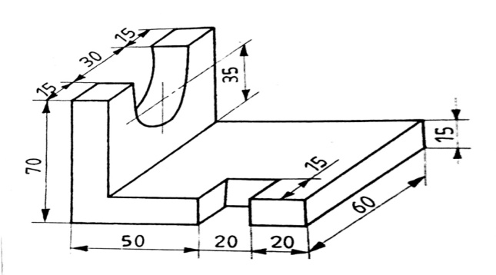 | [10M]
16. | a) | Define CAD? Explain its advantages. | [5M]
 | b) | List out editing commands, drawing commands. | [5M]
17. | a) | Define eccentricity? Explain about conic sections. | [3M]
 | b) | Differentiate between first angle projection and third angle projection. | [4M]
 | c) | Differentiate between plane and solid. | [3M]
18. | a) | A square prism its base side 25mm and axis height 60mm perpendicular to HP, resting with its base on HP, such that one of its face 10mm in front of VP and perpendicular to VP. Draw its projections. | [3M]
 | b) | Define Computer aided drafting? Explain its advantages . | [4M]
 | c) | list out editing commands. | [3M]

-- 00 -- 00 –

